ACSL
American Computer Science League
2012 - 2013

Contest #1

Senior Division

1. Recursive Functions
Find ((((20)))) given:

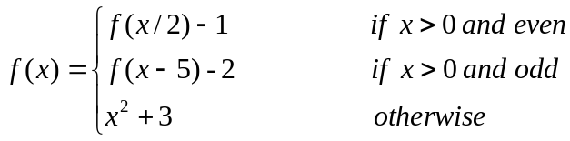

- Recursive Functions
Find (2, 12) given:

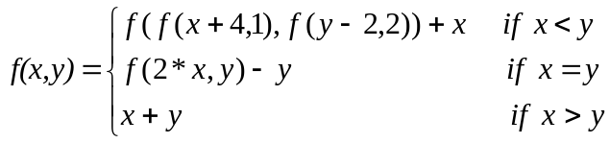
3. Computer Number Systems
Find the mean (average) of the following numbers and express it
in octal.
170₈ 144₁₀ 1110000₂ 97₁₆ 200₈

4. Computer Number Systems
Solve for X₁₆:
1011011₂ + 2 * X₁₆ = 7321₈

- Assembly Language
What is the final value of N when the program is run?
A DC 10
N DC 0 SUB =1
TOP LOAD A STORE A
MULT A BG TOP
STORE B PRINT N
LOAD N END
ADD B
STORE N
LOAD A

